**NAAN MUDALVAN ASSIGNMENT**

**NAME:** MEERAN AZARUDEEN.M

**DEPARTMENT**: B.E COMPUTER SCIENCE ENGINEERING

**COLLEGE**: 8151 DHANALAKSHMI SRINIVASAN INSTITUTE OF TECHNOLOGY

**NAANMUDHALVAN COURSE**: DIGITAL MARKETING

**NM ID**: 34FBD181A13027FB5114052B006D5B2B

ASSIGNMENT 1:

Create a blog or website using Blogspot and word press. Customize the theme design and post new article with 500 words.

URL: https://zorodanceacademy002.blogspot.com/2023/08/unveiling-enchanting-world-of-dance.html

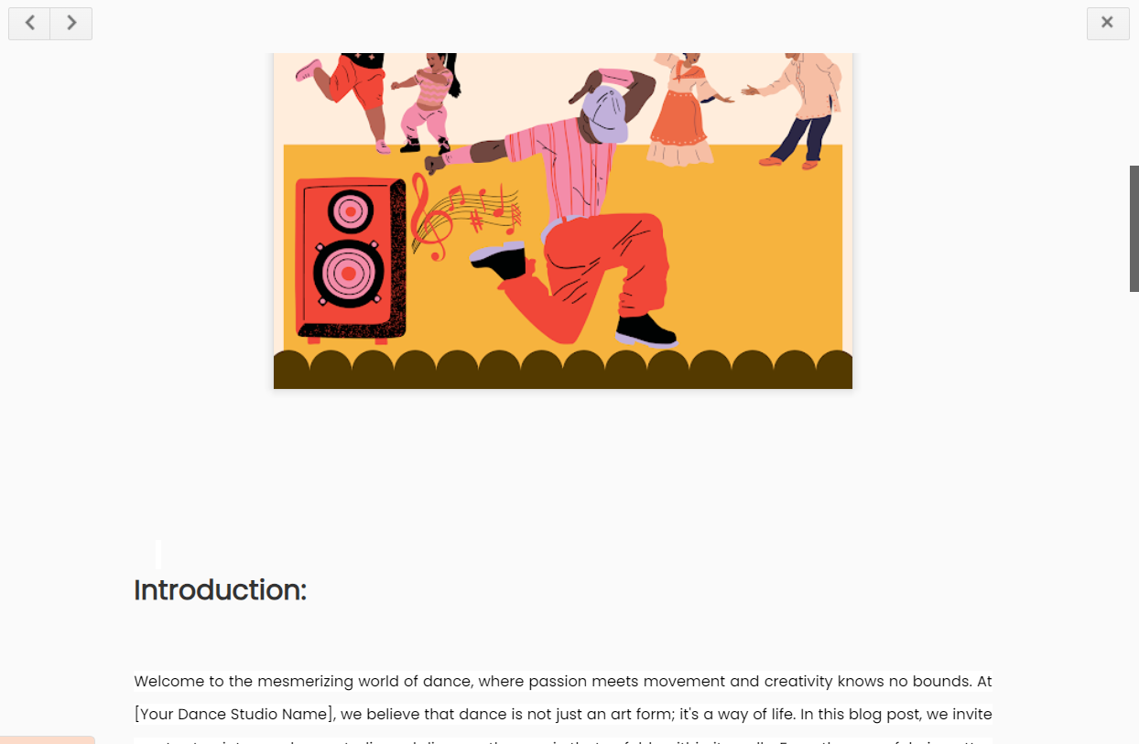

ASSIGNMENT 2:

Create a new Facebook business page and post one social media poster for your brand.

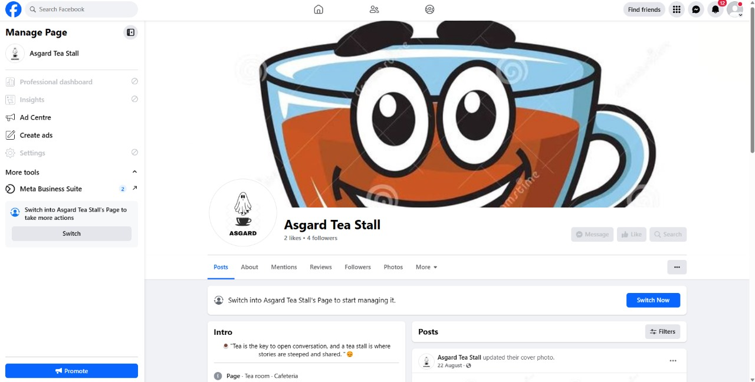URL: https://www.facebook.com/profile.php?id=61550345822150

ASSIGNMENT 3:

Create and design a advertisement poster using Canva.

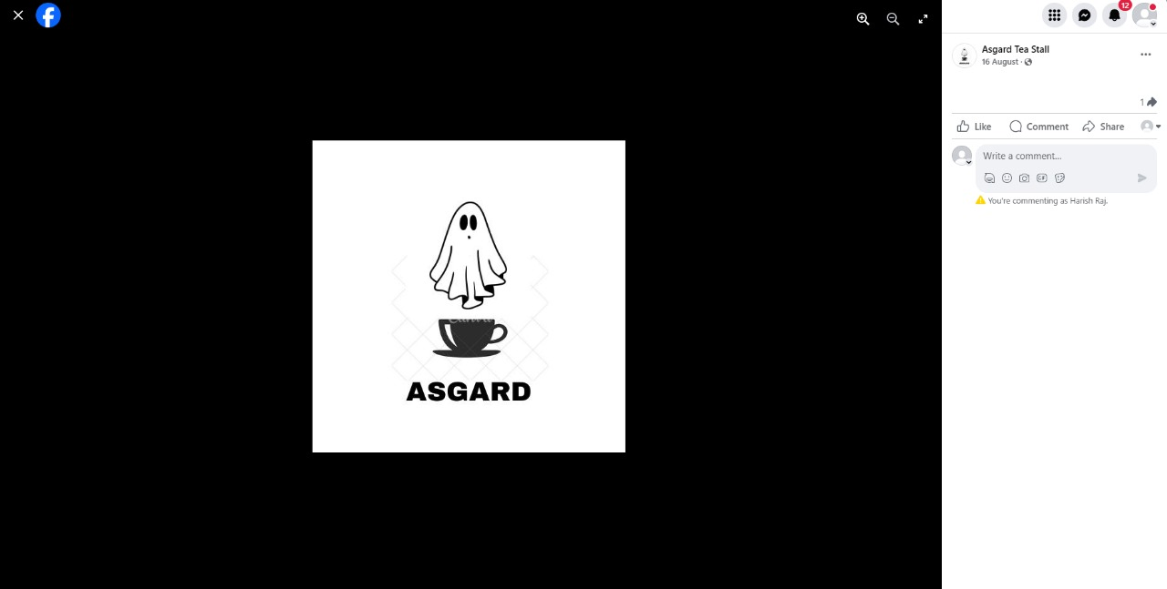URL: <https://www.facebook.com/photo/?fbid=122102471894011527&set=pb.61550345822150.-2207520000>

ASSIGNMENT 4:

Create an E mail newsletter design using Mailchimp or Canva tool.

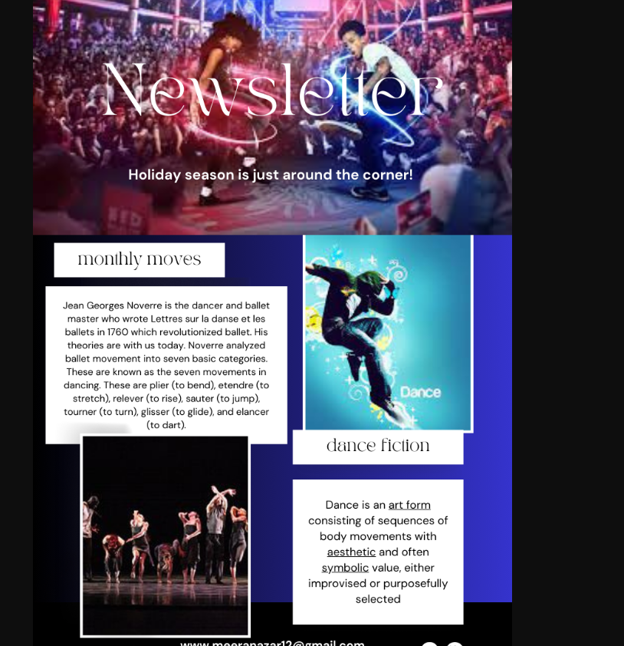URL: https://zorodanceacademy002.blogspot.com/2023/08/email-news-zoro-dance-studio.html